These guidelines are to be utilized for Inbound Shipments to Chefs’ Toys and are applicable to shipments into our Fountain Valley, CA and Anaheim, CA warehouses and for Drop Shipments Direct-to-Customer where the Purchase Order states: **Ship via Chefs’ Toys Routing Guide.**

**Transportation Mode**—**Small Parcel / Less-Than-Truckload (LTL) / Truckload**—is based on four factors:

1. Total carton count of the shipment
2. Total weight of the shipment
3. Dimensions and weight of the cartons within the shipment
4. Total linear feet of trailer space required for the shipment

**SMALL PARCEL MODE**

**Ship via:** corp_logo**Ground**

Choose “Recipient” for “Bill Transportation To”

Enter **[Account# provided by TriMark]** in “Account No.” field

**Use Small Parcel Mode when:**

**Carton Count:** 20 cartons or less

AND

**Total Weight:** 250 lbs. total weight or less

AND

**Individual Carton Size and Weight:**

[length + girth] is less than or equal to 130 inches for ALL cartons within shipment. Length cannot exceed 108 inches and weight cannot exceed 150 lbs. for each carton

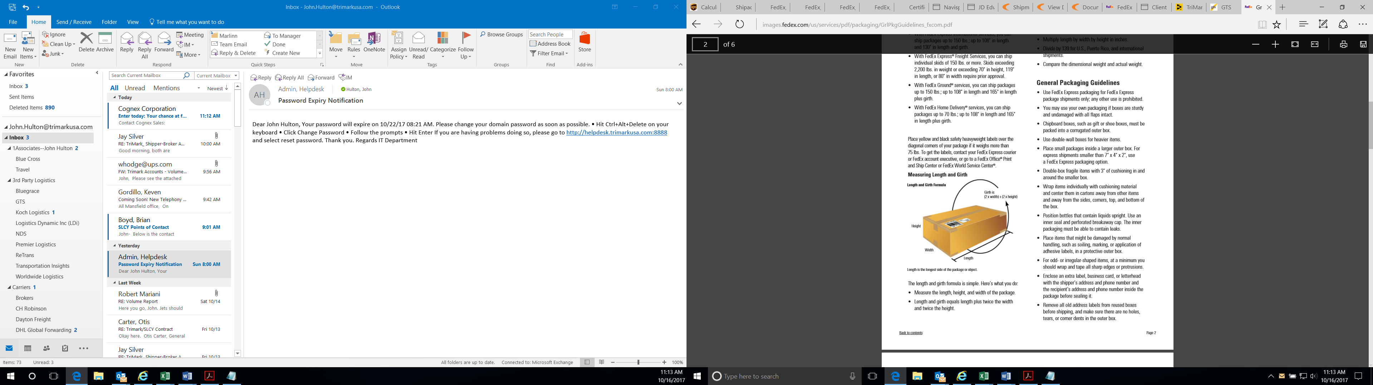

***\*Length is always the longest side of the carton***

**LESS-THAN-TRUCKLOAD (LTL) MODE**

[](https://www.google.com/url?sa=i&source=images&cd=&cad=rja&uact=8&ved=2ahUKEwjDtum2y4XbAhUCn-AKHRC_DwwQjRx6BAgBEAU&url=http://www.onestopshipping.com/&psig=AOvVaw1nEHzkZ8i27j_qmhu_QKsf&ust=1526400583421883)

**Email** [TriMark@ascentgl.com](mailto:TriMark@ascentgl.com)or **Call** (800) 699-9316for carrier assignments. **Ascent Global Logistics** will provide a Bill of Lading for the shipment.

**Use LTL Mode when:**

**Carton Count:** Greater than 20 cartons

AND/OR

**Total Weight:** Between 250 lbs. and 5000 lbs.

AND/OR

**Individual Carton Size and Weight:**

[length + girth] is greater than 130 inches for at least one carton within the shipment, and/or at least one carton is greater than 108 inches in length or 150 lbs.

Example: [Length + Girth]

\*Length = 16 inches

Width = 12 inches

Height = 10 inches

Length + (2x Width) + (2x Height) = 60 inches

**TRUCKLOAD MODE**

[](https://www.google.com/url?sa=i&source=images&cd=&cad=rja&uact=8&ved=2ahUKEwjDtum2y4XbAhUCn-AKHRC_DwwQjRx6BAgBEAU&url=http://www.onestopshipping.com/&psig=AOvVaw1nEHzkZ8i27j_qmhu_QKsf&ust=1526400583421883)

**Contact:** [Trimark@ascentgl.com](mailto:Trimark@ascentgl.com), or call (800) 699-9316 for carrier assignment. **Ascent Global Logistics** will provide Bill of Lading for shipment.

**Use Truckload Mode when:**

**Total Weight:** Greater than 5000 lbs.

AND/OR

**Trailer Space Required:** 25 linear feet of trailer space or greater

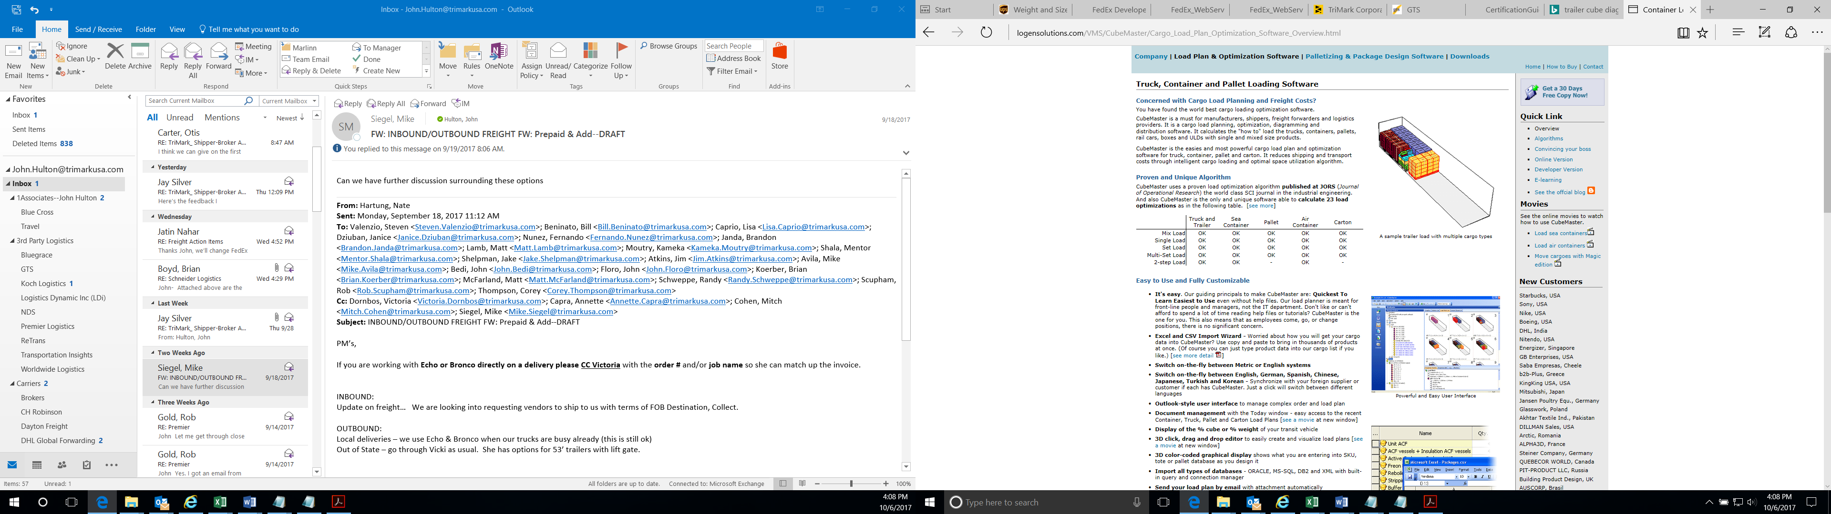

*Sample shipment with mixed merchandise greater than 5000 lbs. total taking up 25 linear feet of trailer space*

**Please provide the following shipment information:**

* Origin Address
* Destination Address
* Pickup Date
* Delivery Date
* Purchase Order Number(s)
* Total Weight
* Total Pieces and/or Total Pallet Count with Pallet Dimensions (length/width/height)
* National Motor Freight Classification (NMFC) and/or commodities of item(s) in shipment—If multiple NMFC’s, please provide total weight and total piece/pallet count for each NMFC within the shipment

**IMPORTANT NOTES FOR ALL SHIPMENTS**

* All Chefs’ Toys purchase orders shipping to the same destination on the same date should be combined onto one bill of lading.
* Freight Collect shipments should not be shipped Prepaid & Add. All Freight Collect shipments that are shipped Prepaid & Add will have the freight charges deducted from the invoice payment.
* If you do not have a FedEx account, please call FedEx at (800) 463-3339 to set one up.
* For shipments that need expedited transportation, please contact the assigned Buyer for your account at (714) 665-CHEF if specific instructions are not included on your purchase order.